**Conversation system regex**

Text is parsed with a regular expression.

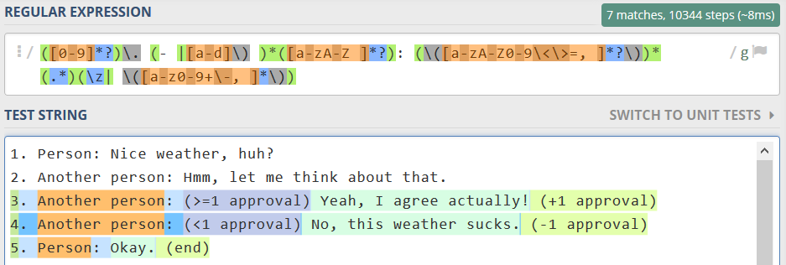

Voor een dialogue systeem wil ik een regular expression waarmee alle 5 deze zinnen gevonden worden. De laatste groep (met tekst tussen haakjes) wil ik optioneel capturen; als die er niet is, wil ik alsnog de rest van de zin hebben.

Harry: Can I get the day off tomorrow?  
This line shows the player (Harry)’s face on the right side of the dialogue window and lets them say “Could I get the day off tomorrow?”

Barrington: Hmmm...  
If another person than Harry speaks, they are shown on the left side of the dialogue window. Their face sprite is fetched based on the name.

Barrington: (5 work approval) Why not. You’ve been working hard enough lately.   
If brackets are found after the : sign, the game parses the text inside. If it contains a number followed by work/partner/friend/mom approval (based on regex),

harry: How'd you like this?

barrington: Hmmm... let me think about that.

-a) Yes, of course! (+1 mom approval, +1partner approval, +1work approval, +1family approval, +1 day taken off, +1 mom missed text)

-b) Sorry, I don't have the time. (-1ts, +1s)

harry:

barrington:

/>

- b:

- c:

- d: